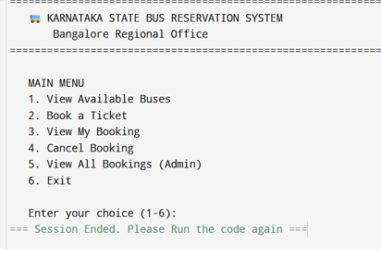
2. Viewing Available Buses
Input:
Enter your choice (1-6): 1
Output:

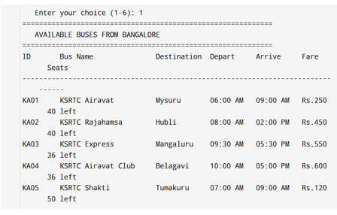
3. Booking a Ticket (Entering Details)
Input:
Enteryourchoice(1-6):2
EnterBusID:KA03
EnterPassengerName:mahitha
EnterAge:18
EnterGender:F
EnterPhoneNumber:9345671829
Enter number of seats: 2
Output:
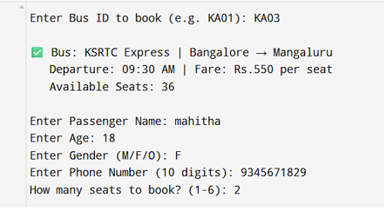
Booking Confirmation
Input:
Confirm Booking: yes

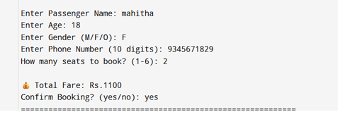
Input:
Booking completed
Output:

